SCHEME OF EVALUATION

KAKATIYA INSTITUTE OF TECHNOLOGY & SCIENCE, WARANGAL
(An Autonomous Institute under Kakatiya University, Warangal)
FACULTY OF ENGINEERING AND TECHNOLOGY
B.TECH/M.TECH/MBA END SEMESTER EXAMINATION
(Regular/Supplementary: Month, Year)
SEMESTER
BRANCH
COURSE CODE
COURSE NAME

Prepared by
Name: |  | Designation: |  | Department:

// This is Sample SoE only. Use the template attached with the mail for preparation of SoE//
Instructions to the Evaluator:
- If the student answers with any alternate method, it should be valued and suitably awarded.
- All answers (including extra and repeated) have to be considered for valuation. Answer with maximum marks awarded must be considered for final award for a particular question.
- If the student has written wrong question number, it is requested to consider for valuation and allot marks to correct question number.

 |  |  |  | Marks |  | CDLL | CO
1. | Short answer type questions covering contents of Unit-I, Unit-II, Unit-III & Unit-IV.
 | i. | State Ohm’s law  - Correct statement or v=iR 1 Mark | [1] |  | R |  | CO1
 | ii. | How can you say that an element is linear?  - Definition (V–I linear relationship) : 1 Mark | [1] |  | R |  | CO1
 | iii. | How can you transform a practical voltage source into an equivalent practical current source?  - Voltage source in series with R ↔ Current source in parallel with R : 1 Mark | [1] |  | R |  | CO1
 | iv. | What do you mean by a bilateral element? List any two bilateral elements  - Definition : 1 Mark  - Two examples : 1 Mark | [2] |  | U |  | CO1
 | v. | What is the value of internal resistance of an ideal voltage source?  - Zero : 1 Mark | [1] |  | R |  | CO2
 | vi. | If the Thevenin’s voltage and Thevenin’s resistance of a circuit be 10V and 100 ohms, what will be the maximum power transferred to the load?  - correct answer : 1 Mark | [1] |  | R |  | CO2
 | vii. | State one limitation of superposition theorem.  - Not applicable for power calculation : 1 Mark | [1] |  | U |  | CO2
 | viii. | State reciprocity theorem  - Correct statement : 2 Marks | [2] |  | U |  | CO2
 | ix. | What is the frequency of the domestic AC supply available in India?  - 50 Hz : 1 Mark | [1] |  | R |  | CO3
 | x. | For a pure sinusoidal signal, if the rms value of the voltage is 100V, what will be its peak value?  - correct answer : 1 Mark | [1] |  | R |  | CO3
 | xi. | List any two advantages of 3-phase AC over 1-phase AC.  - Any one valid point : 1 Mark | [1] |  | R |  | CO3
 | xii. | Define resonant frequency. Calculate resonant frequency of a series RLC circuit with the following parameters.  - Definition : 1 Mark  - Correct answer: 1 Mark | [2] |  | U |  | CO3
 | xiii. | Write the equation of emf for a single-phase transformer.  - Correct answer: 1 Mark | [1] |  | R |  | CO4
 | xiv. | List any two applications of induction motor.  - Any two applications : 1 Mark | [1] |  | R |  | CO4
 | xv. | List any two limitations of circuit breaker.  - Any valid limitation : 1 Mark | [1] |  | R |  | CO4
 | xvi. | What are the materials commonly used for fuses. What are the properties that make these materials suitable for fuse applications?  - Materials : 1 Mark  - Properties : 1 Mark | [2] |  | U |  | CO4
2. | Questions covering contents of Unit-I of the syllabus.
 | i. | For the circuit shown below in fig.1, determine current in 4 ohms resistor using nodal analysis. Clearly show all steps.  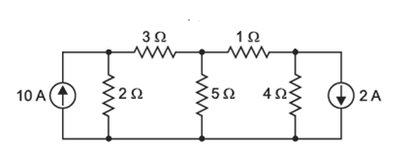  Fig.1  - Steps involved : 1 mark  - Formation of node equations : 2 Marks  - Solving node voltages : 5 Marks  - Current through 4Ω resistor : 2 Marks | [10] |  | Ap |  | CO1
 | ii. | For the circuit given in Fig.2, determine the equivalent resistance between terminals A and B using star-delta transformation. Show intermediate equivalent circuits.  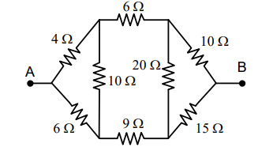  Fig.2  - Identification of star/delta network : 1 Marks  - Correct transformation formulae : 2 Marks  - Step-by-step reduction of network : 6 Marks  - Final equivalent resistance : 1 Marks | [10] |  | Ap |  | CO1
(OR)
 | iii. | For the circuit shown below in fig.3, using mesh analysis, determine the currents supplied by each of the five batteries. Clearly show all steps.  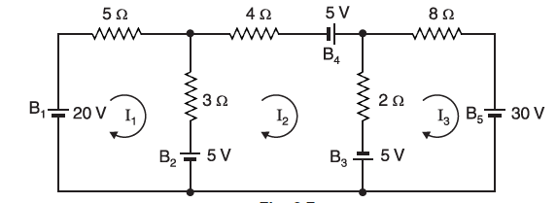  Fig.3.  - Application of KVL (mesh analysis) : 1 Mark  - Formation of mesh equations : 2 Marks  - Solving mesh currents : 5 Marks  - Current supplied by each source : 2 Marks | [10] |  | Ap |  | CO1
 | iv. | For the circuit shown below in fig.4, using nodal analysis, determine the voltage drop and power dissipated in the 5Ω resistor. Clearly show all steps.  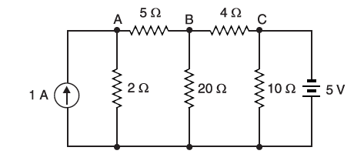  Fig.4.  - Application of KCL (nodal analysis) : 1 Mark  - Formation of node equations : 2 Marks  - Solving node voltages : 4 Marks  - Voltage across 5Ω resistor : 1 Mark  - Power dissipated in 5Ω resistor : 2 Marks | [10] |  | Ap |  | CO1
3. | Questions covering the contents of Unit-II of the syllabus.
 | i. | For the network shown in Fig.5, using superposition theorem, determine the voltage drop across the 20Ω resistor and verify the theorem.  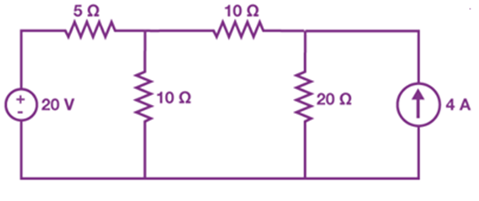  Fig.5.  - Statement of superposition theorem : 1 Mark  - Analysis with both sources active : 3 Marks  - Contribution of individual sources : 4 Marks  - Verification of theorem : 2 Marks | [10] |  | Ap |  | CO2
 | ii. | For the network shown in Fig.6, determine Norton’s equivalent circuit across 5 ohms load resistor and calculate the load current.  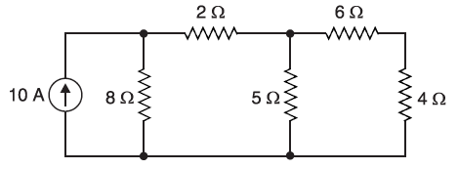  Fig.6  - Statement of theorem : 1 mark  - Short circuit current (Norton current) : 3 Marks  - Equivalent resistance : 3 Marks  - Norton equivalent circuit : 1 Marks  - Load current calculation : 2 Marks | [10] |  | Ap |  | CO2
(OR)
 | iii. | For the network shown below in Fig.7, determine Thevenin’s equivalent circuit across the 23 ohms resistor (load resistance) and calculate the load current,  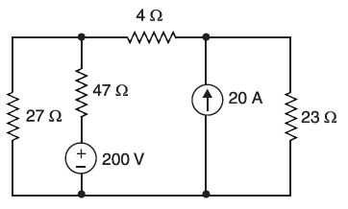  Fig.7  - Statement of theorem : 1 mark  - Open circuit voltage (Thevenin voltage) : 3 Marks  - Equivalent resistance : 3 Marks  - Thevenin equivalent circuit : 1 Marks  - Load current calculation : 2 Marks | [10] |  | Ap |  | CO2
 | iv. | For the network shown in Fig.8, determine the maximum power that can be transferred to the load resistance R_{L}.  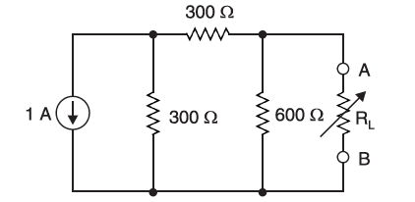  Fig.8  - Statement of maximum power transfer theorem : 1 Mark  - Thevenin voltage : 3 Marks  - Thevenin resistance : 3 Marks  - Maximum power calculation : 3 Marks | [10] |  | Ap |  | CO2
4. | Questions covering contents of Unit-III of the syllabus.
 | i. | For the signal shown in fig .9, determine the average value and RMS value of the waveform. Clearly show all steps.  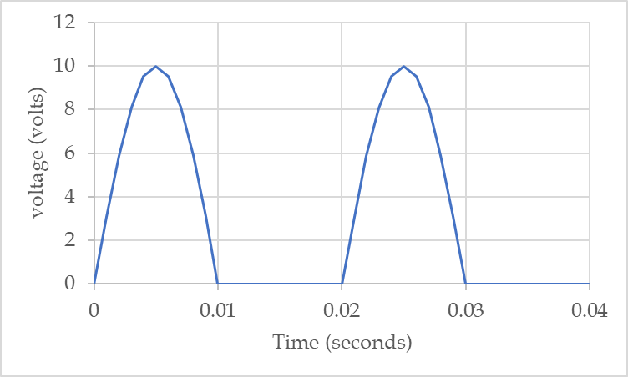  Fig.9  - Identification of waveform and mathematical expression : 2 Marks  - Average value calculation : 4 Marks  - RMS value calculation : 4 Marks | [10] |  | Ap |  | CO3
 | ii. | A single-phase AC circuit consists of an inductance of 25mH, a capacitance of 318μF connected in series with 10 ohms resistor across a 415, 50Hz supply. Determine the impedance, current, power factor, and voltage drops across all elements of the circuit.  - Reactance calculations (XL, XC) : 2 Marks  - Impedance calculation : 2 Marks  - Current calculation : 2 Marks  - Power factor : 1 Mark  - Voltage drops across elements : 3 Marks | [10] |  | Ap |  | CO3
(OR)
 | iii. | A single-phase AC circuit consists of a capacitance of 318.47μF connected in series with 10 ohms resistor across a 400, 50Hz supply. Determine the impedance, current, power factor, and voltage drops across all elements of the circuit.  - Impedance calculation : 3 Marks  - Current calculation : 2 Marks  - Power factor : 1 Mark  - Voltage drops across elements : 4 Marks | [10] |  | Ap |  | CO3
 | iv. | A three-phase star connected circuit consists of an impedance of (5+j12) ohms/phase connected across a 3-phase supply of 230V, 50Hz. Sketch the circuit and determine phase currents, line currents, power factor, active power, and reactive power.  - Circuit sketch : 2 Marks  - Phase and line currents : 3 Marks  - Power factor : 1 Mark  - Active and reactive power : 4 Marks | [10] |  | Ap |  | CO3
5. | Questions covering contents of Unit-IV of the syllabus.
 | i. | Explain the operating principle of a transformer and derive the EMF equation. A 1-phase transformer, rated 25kVA, has 200 turns on the primary and 150 turns on the secondary. The maximum flux linking both the coils is 50mWb and the frequency of the supply is 50Hz. For the given data, determine the induced EMF in primary and secondary windings and the currents.  - Operating principle of transformer : 2 Marks  - EMF equation derivation : 3 Marks  - EMF calculation (primary & secondary) : 3 Marks  - Current calculation : 2 Marks | [10] |  | An |  | CO4
 | ii. | Select a suitable single-phase induction motor for the given application and justify your choice. Explain its working with a neat diagram. Also determine the approximate current drawn.  A gardener needs to install a water pump to lift water from a depth of 5 meters and supply it to the garden. The pump operates on 230 V single-phase AC supply and requires a motor with 1 HP power rating.  - Selection of suitable motor : 2 Marks  - Justification for selection : 2 Marks  - Working principle explanation : 3 Marks  - Neat diagram : 1 Mark  - Current calculation : 2 Marks | [10] |  | An |  | CO4
(OR)
 | iii. | Identify the causes of electrical shock in domestic systems and suggest preventive measures. Explain the process of earthing with a neat diagram.  - Causes of electrical shock : 3 Marks  - Preventive measures : 3 Marks  - Earthing explanation : 2 Marks  - Neat diagram : 2 Marks | [10] |  | An |  | CO4
 | iv. | A manufacturing unit is setting up its electrical system, and the following requirements are provided:  - The unit operates various machinery and electrical equipment with a total load of 100 kW.  - The equipment includes sensitive machinery, lighting systems, and office electronics.  - The company needs to protect the circuits from overloads, short circuits, and potential faults.  Select a suitable protective device (Fuse or MCB) for the given application and justify your choice. Explain its working with a neat diagram. Also determine the required current rating.  - Selection of protective device : 1 Marks  - Justification : 2 Marks  - Working principle : 3 Marks  - Neat diagram : 2 Mark  - Current rating calculation : 2 Marks | [10] |  | An |  | CO4

